Project Design Phase-II
Data Flow Diagram & User Stories
Date | 28 steptember 2026
Team ID | SWTID-2026-3622
Project Name | Import Data using Transform Maps
Maximum Marks | 4Marks

- Data Flow Diagram (DFD - Level 1):
The flow chart visualizes the path of data from the external spreadsheet file to the target database table:

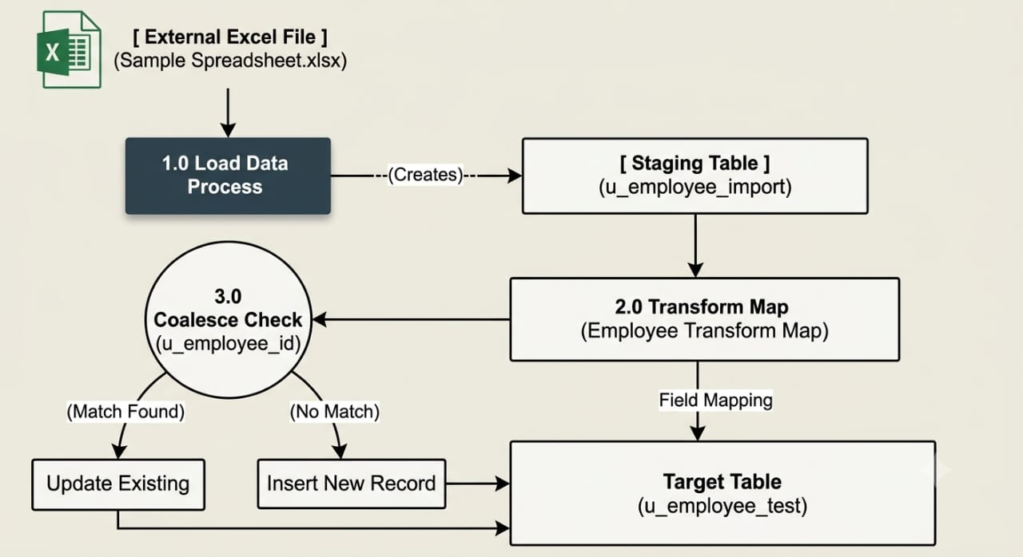

2.User Stories Template:

User Type | Functional Requirement (Epic) | User Story Number | User Story / Task | Acceptance Criteria | Priority | Release
Administrator | Target Table Setup | USN-1 | As an Administrator, I want to create a custom table Employee Test (u_employee_test) so that imported employee records can be stored safely | Table exists with custom string fields (Employee ID, Employee Name, Email, Department, Location). | High | Sprint-1
Data Ops Specialist | Data Staging | USN-2 | As a Data Ops Specialist, I want to upload Sample Spreadsheet.xlsx via System Import Sets so that raw data is staged before processing. | Import Set staging table u_employee_import is populated with raw spreadsheet rows. | High | Sprint-1
System Admin | Transform Mapping | USN-3 | As a System Admin, I want to create Employee Transform Map and use Auto Map Matching Fields so that source columns map automatically to target fields. | All 5 source columns automatically pair with corresponding fields on u_employee_test | High | Sprint-1
Data Governance Lead | Duplicate Prevention | USN-4 | As a Data Governance Lead, I want to set Coalesce on Employee ID so that existing records are updated rather than duplicated. | Re-running the transform updates existing records if Employee ID matches, creating new records only when unique. | High | Sprint-2
System Admin | Execution & Verification | USN-5 | As a System Admin, I want to run the transform script and review logs so that I can ensure 100% data ingestion accuracy. | Transform completes with state Complete and 0 errors reported in Import Set Run logs. | Medium | Sprint-2

